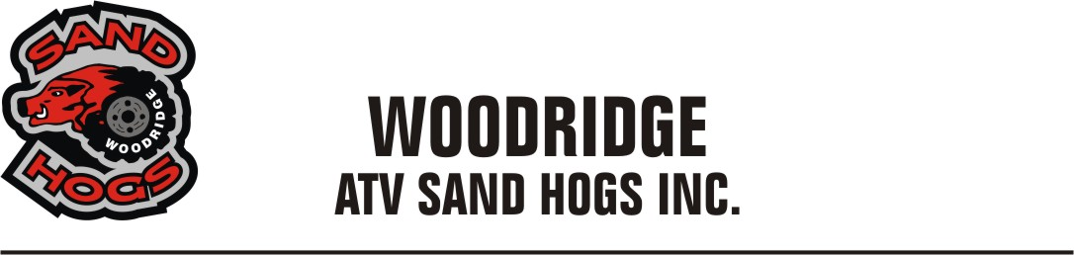
2021 Application Form
The Woodridge ATV Sandhogs, through education, training and collaboration with ATV.MB strive to:
- Promote and encourage the safe and responsible use of ORV’s
- Promote environmentally – friendly ORV use on crown lands or private lands
- Represent the interest of all ORV riders in Manitoba
- To develop and maintain our designated Atv trail system
- Be Stewards of the lands
Please provide us with information below so that we can show our partners who we represent:
Name: ______________________________________________________________________________
Address: ____________________________________________________________________________
City: ____________________________________Province:____________________________________
Postal Code: _____________________________Phone#:_____________________________________
Email: _______________________________________________________________________________
Machine info ( optional )
Make: _____________________________Model:__________________________Year:_____________
Make: _____________________________Model:__________________________Year:_____________
Make: _____________________________Model:_________________________Year:______________
Questions/Comments:______________________________________________________________________________________________________________________________________________________ Annual Membership is $30.00 for a single and $45.00 for a family . Please make payable to : WOODRIDGE SANDHOGS . Thank you .Please mail your completed form to Gary Hora, Box 19 Woodridge MB, R0A-2N0.

